Chapter 19, Solution 73.

Three copies of the circuit shown in Fig. 19.70, are connected in cascade. Determine the z parameters.
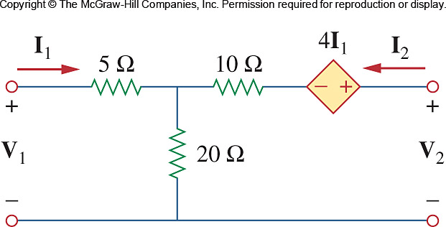

Figure 19.70
For Probs. 19.6 and 19.73.

Solution

From Problem 19.6,

The overall ABCD parameters can be found using MATLAB.

>> T=[25/24,270/24;1/24,30/24]
T =
1.0417 11.2500
0.0417 1.2500
>> T3=T*T*T
T3 =
2.6928 49.7070
0.1841 3.6133
>> Z=[2.693/0.1841,(2.693*3.613-0.1841*49.71)/0.1841;1/0.1841,3.613/0.1841]
Z =
14.6279 3.1407
5.4318 19.6252

[Z] =

